**ADVERT SYSTEM MANAGEMENT DOCUMENTATION**

This project is aimed at developing an Advertisement Management system useful

to admin to manage the different advertisement. The

Advertisement Management System [AMS] is a web-based application that can be

accessed online. This web application can be used to store all the information about

different advertisement.

The project entitled “Advert System Management” the main aim

of the project is to provide live advertisements with the users selected images

Main aim of this project is to provide a web based

application for advertising, to take orders from clients and improve

chances of advertising business by going online. The main theme is to provide

advertisement in form of text, images. This project is a service business dedicated

to creating, planning and handling advertisements for its clients. Customers can

choose the advertisement types for the advertisements to be registered through contacting the admin.

The type of ads are:

« Text Classifieds

« Display Adds images

**Objective and Scope of Advertisement Management system**

« To provide proper information briefly

« To provide huge maintenance of records

« Flexibility of transactions can be completed in time

**Modules of the project**

« **Customer Registration**: Here the customer needs to sign up to view and be able to see his Advertisements but he may first negotiate with the admin.

**Advertisements**: -It deals with Advertises uploaded by the admin.

+ Mail:- Customer can receive email after creating registering.

**Dashboard**: the admin advert list dashboard to add, delete or edit adverts

**Advantages:**

« Allows booking and viewing advertisements.

« Enjoy the convenience and time savings

« Simplest ad booking process.

« Choice of Preview your Adds and make payment instantly.

**Languages used**:

« Front End: HTML + CSS

« Backend: SPRING BOOT

**Use case of the project**

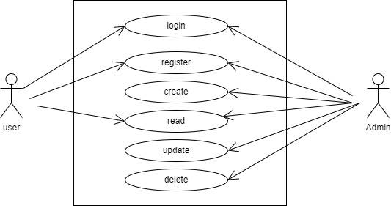

**ER Diagram**

